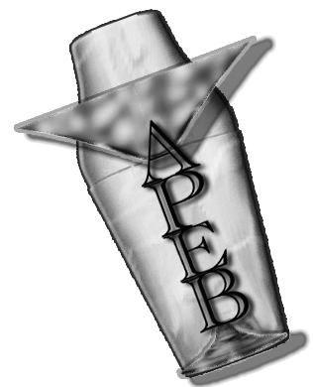 LISTE DES COCKTAILS DU CONCOURS NATIONAL DES JEUNES TALENTS DU BAR

Direct | Au shaker | Au verre à mélange

 | Court |  | Long |  | Court |  | Long |  | Court
1 | Black Russian | 7 | Americano (stick) | 16 | Amaretto Sour (old fashioned) | 29 | Barbottage | 37 | Dry Martini –Tequini –  Vodkatini
2 | Bourbon & Cognac Old Fashioned | 8 | Bloody Mary (stick/paille) | 17 | Bacardi Cocktail | 30 | Bonneveine (stick/paille) | 38 | Manhattan
3 | Caïpirinha | 9 | Champagne Cocktail | 18 | Bronx | 31 | Clin d’oeil (stick/paille) | 39 | Martinez
4 | Negroni | 10 | Mojidos (stick/paille) | 19 | Corpse Reviver n°2 | 32 | Corsica (stick/paille) | 40 | Presidente
5 | Bramble | 11 | Mojito (stick/paille) | 20 | Cosmopolitan | 33 | French 75
6 | Summit | 12 | Tampico (stick) | 21 | Daiquiri | 34 | Gin Fizz (paille)
 |  | 13 | Ti Punch Contemporain | 22 | Last Word | 35 | Pina Colada (stick/paille)
 |  | 14 | Tequila Sunrise (stick/paille) | 23 | Margarita | 36 | Sunset Boulevard (Sex on the Beach) (stick/paille)
 |  | 15 | Spritz Veneziano (stick) | 24 | Paradise
 |  |  |  | 25 | Red Lion
 |  |  |  | 26 | Scotch Sour (verre à cocktail)
 |  |  |  | 27 | Side Car
 |  |  |  | 28 | White Lady

